UNIVERSITY SIMULATION ECONOMY DESIGN
Objectives:
The player needs to manage the resources of a university to make it the best in the nation by achieving various in-game goals.

My Desires:
One of the most important aspects of Management Simulation games is the planning and balancing of different resource types. The player needs to utilize these resources to push the game progress or prepare for hazard contingencies. For instance, in Prison Architect, the chance of prisoner rioting gets higher as the prison holds more prisoners.

Many Management Sims on the market share a similar issue: in the early game, they rush to present most of the game system to the players, which makes the learning curve steep. After the player put in the effort to learn the systems, the late game has very little attractions that can keep the player going (Yes, you, Jurassic World Evolution). Some games try to tackle this issue by spawning troubles for players to solve, but this approach is often not effective, as they are merely a high-stat copy of the problems players faced in the early game (An example will be the traffic issue in the late game of Cities: Skylines).

Consequently, we decided to plan out two distinct stages for this game economy. As the player gets too familiar with the economy, we control the economic stats in the mid-game, which eventually turns into a parallel economic system during the late game.

https://drive.google.com/file/d/1fu9BScK1gwi6xJPNJjMNO8SnurD5WoB1/view?usp=sharing
CHECK THIS LINK FOR NUMBERS ⬆

Diagrams of economy:
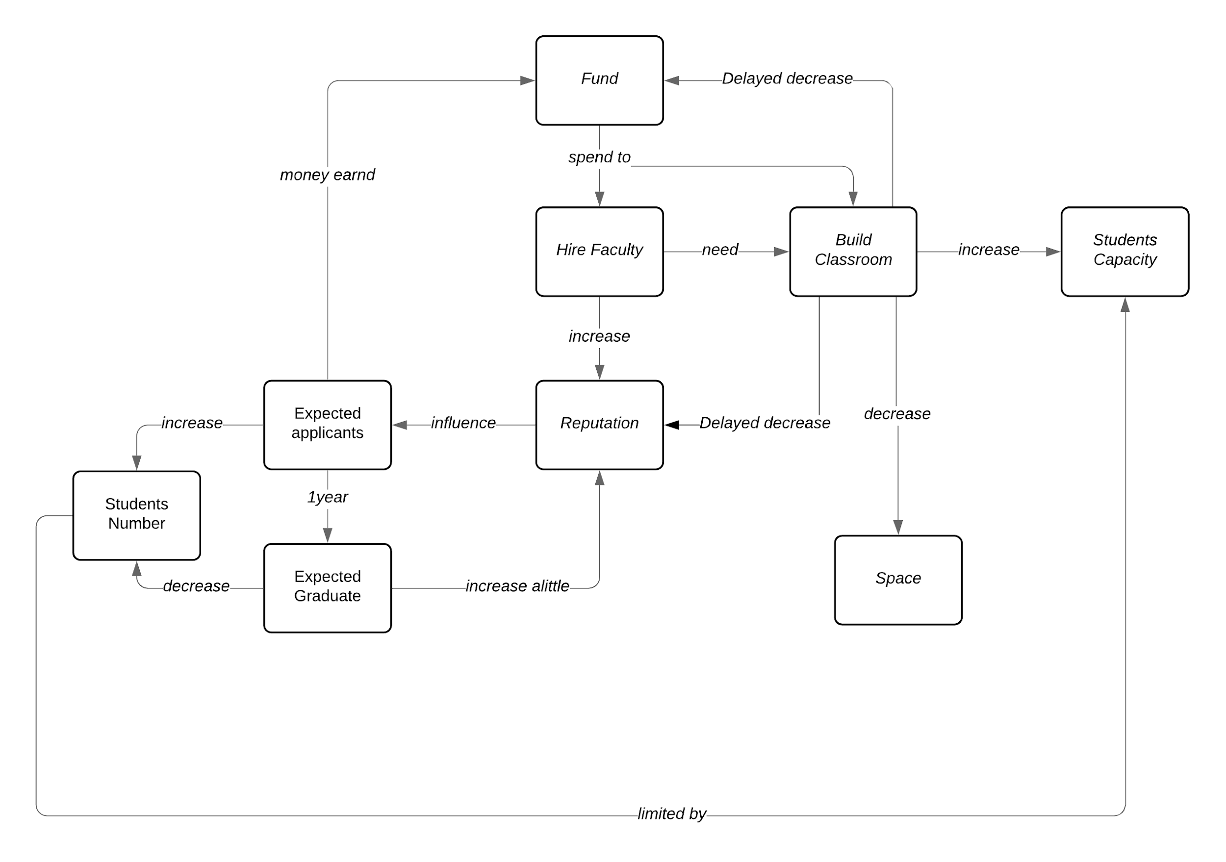

Figure 1. Early game economy system diagram
https://bit.ly/2QnooNV
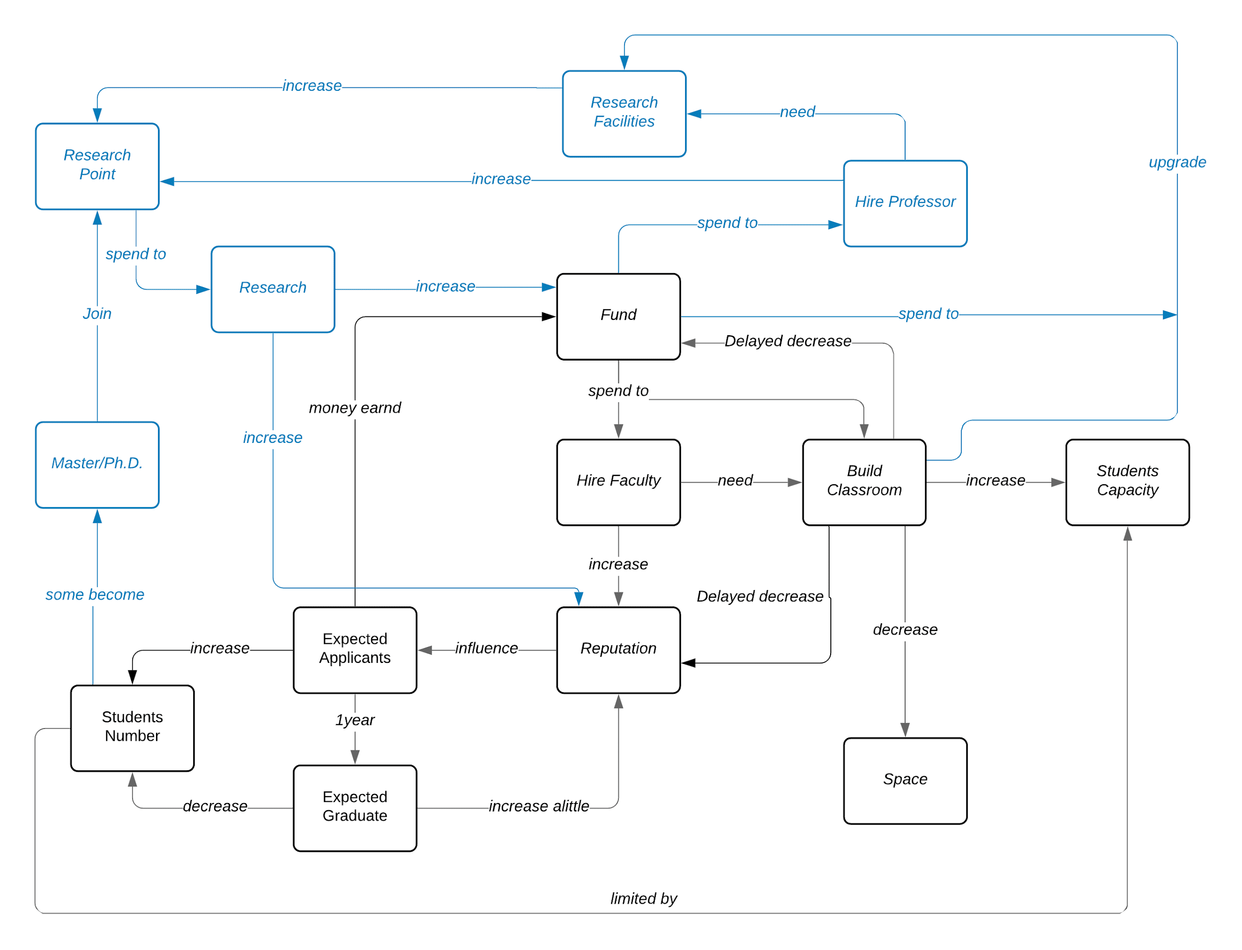
Figure 2. Late game economy system diagram

https://bit.ly/3583I0E

As shown in the diagrams, we wish to differentiate the economy in the early game and late game, while keeping the basic game economy loop. In Figure 2, the blue parts will be added to the game when the player gets to a certain stage.

Detailed breakdown of resources

1. Funding
Funding, or money, is the most basic component of the economic system. As the most basic resource, the player’s every choice relates to it. In the game, the player can get Funding in ways like student tuition. Activities such as building new classrooms, upgrading facilities, hiring employees, all cost funding.
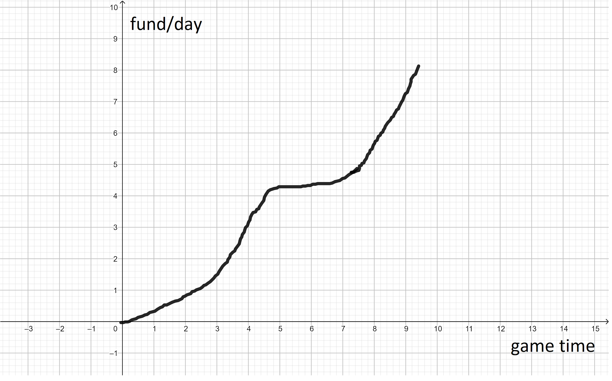
The Game time/Fund curve of the economy

The initial design is to draw out the desired Time/Funding graph because it is the center of the economic system. We wish to control the player’s experience by controlling the amount of funding player has, and use that to control other resources’ flow. Notice the “flat” part of the curve, that is the “middle game” part we mentioned before, during which the player will go through a transition from the early game to late game. In the early game, we allow the player to get funding easily so they can easily explore the system and quickly deplete their space resources. Once they ran out of space, the player will encounter the bottleneck of the gameplay, as they can no longer get funding easily. They will be forced to think better strategies, because their funding no longer increases, or even drops if they make bad decisions. This design’s purpose is to allow the player to realize that they will have to utilize the “late game” economy systems and new resources to progress.

2. Reputation
Reputation represents the school’s public image. The player can increase the school’s reputation by employing better faculties and graduating high-quality students.

We had some problems when designing the reputation system because we realized we don’t have a systematic way to decrease the school’s reputation besides random events. Thus we decided to add on the “Depreciation” attribute of facilities. Basically, facilities like classrooms will require maintenance after they have been built for an amount of time. Without using funding to repair these facilities, the school’s reputation will drop continuously. We hope to use this mechanism to balance out the Reputation-Funding system.

3. Employees-Reputation
Employees have two properties: reputation and recruitment cost. The employee’s reputation will be added to the school’s reputation. The employee with higher reputation cost more funding.

4. Space
Yes, the space of the campus is also an important part of the economy. How to utilize the limited space on campus is also what the player needs to consider. As the game progresses, the limited space will eventually be depleted (space is not replenishable). After the player figured out the entire game system, they build facilities faster and consequently depletes space faster.
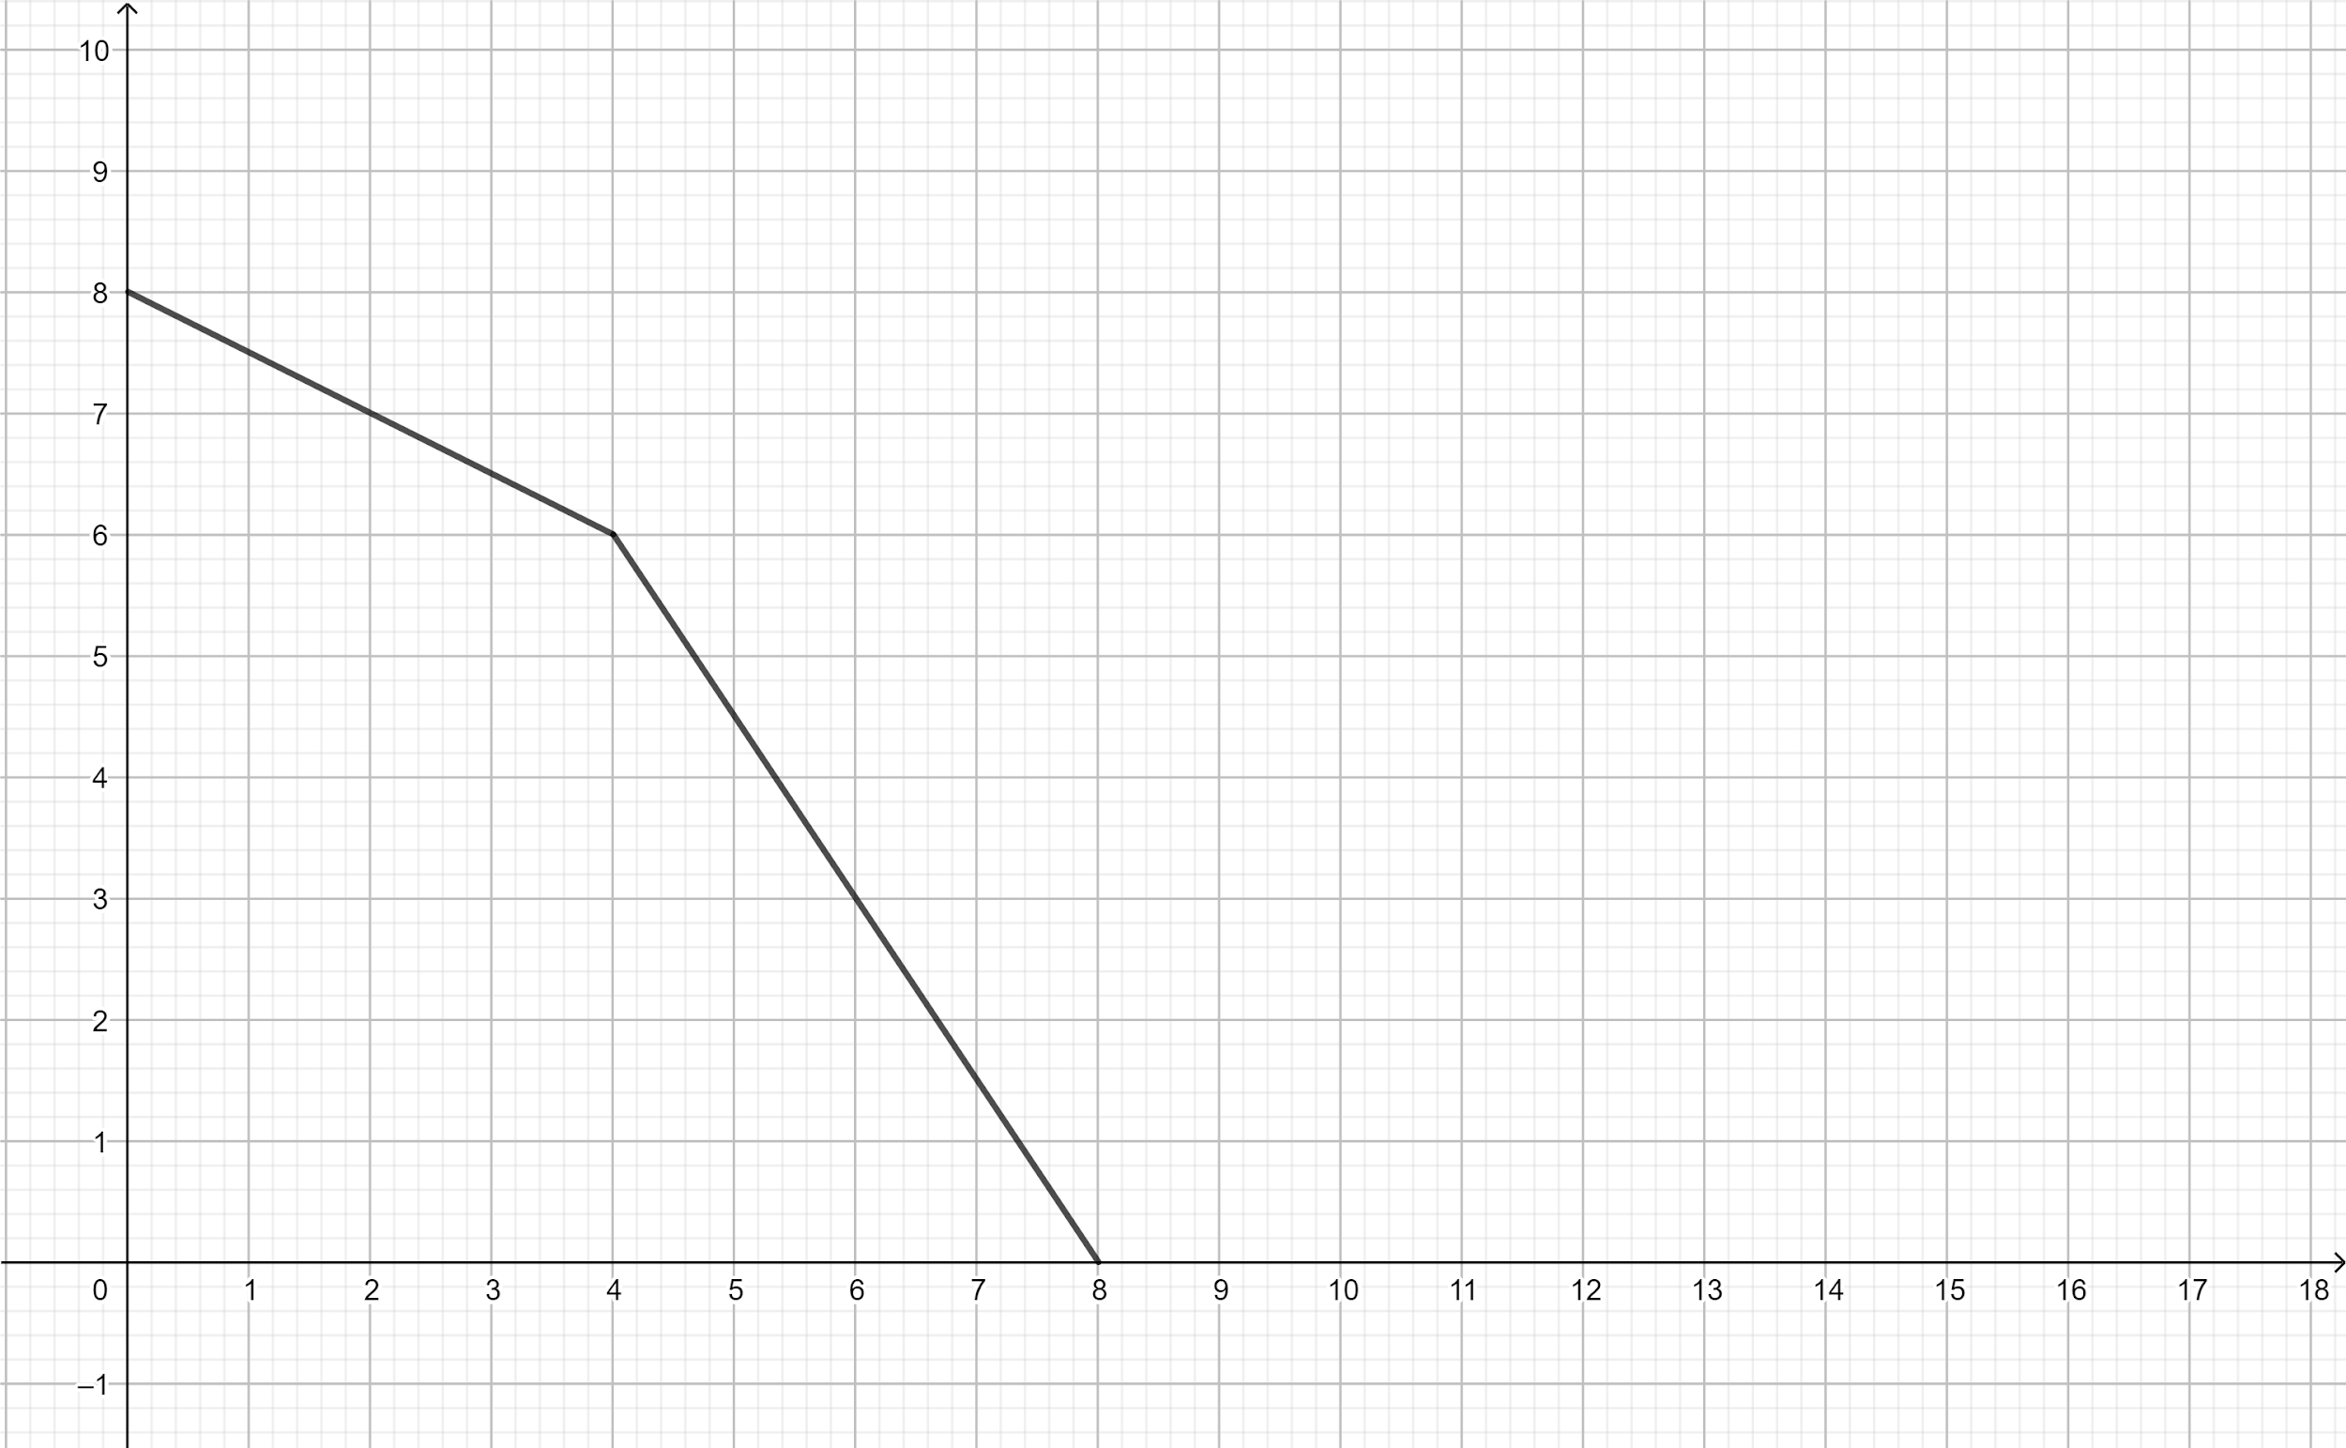
Time-Space
5. Student amount
This resource is straightforward. In the game, “Classroom” controls the maximum amount of students the campus can hold. After the player depleted all space, the student amount will cease to increase, which leads to a pause of their funding increase.
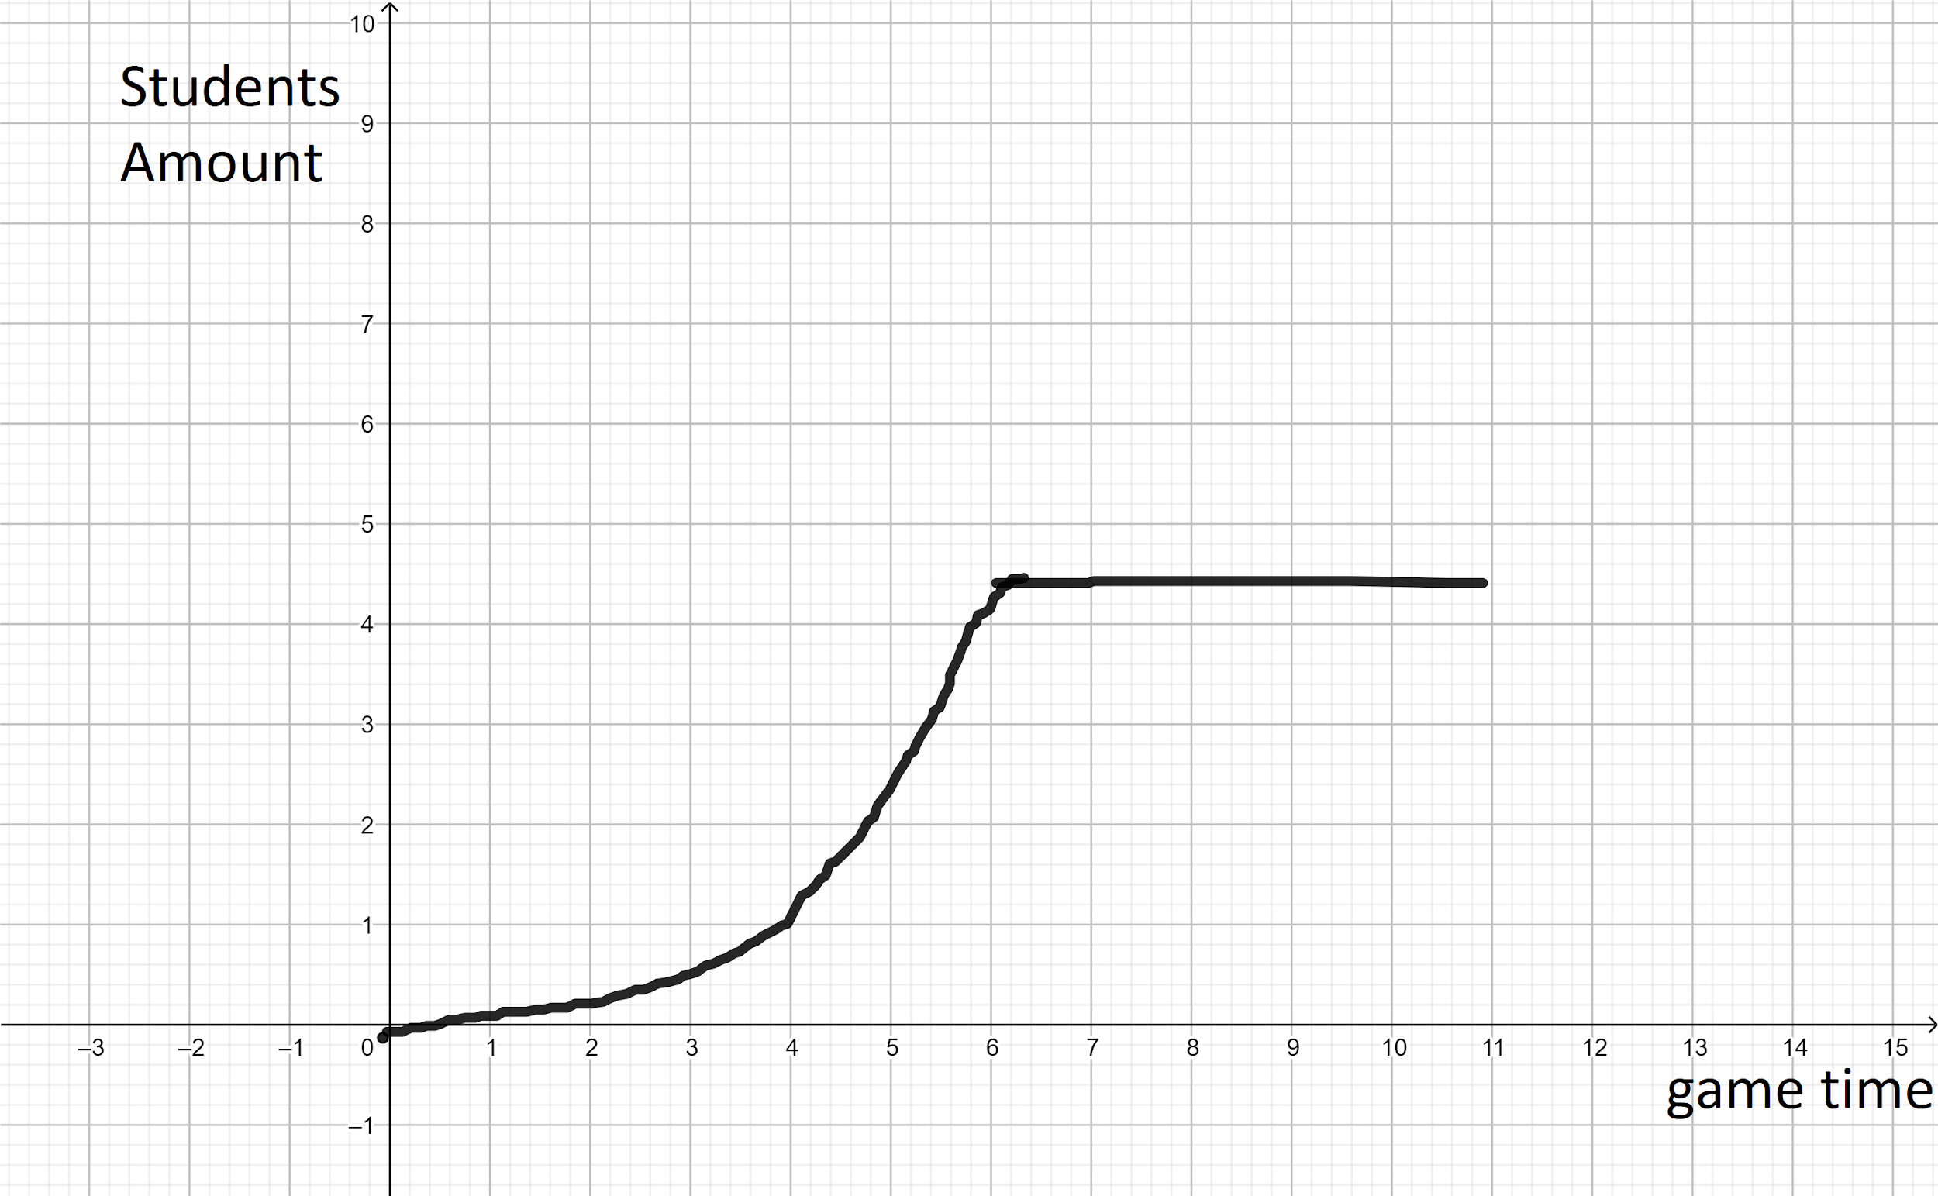
Gametime - student amount
The student’s amount changes every three months. The school will accept new students and graduate seniors. The amount of newly admitted students is positively correlated to the school’s reputation, and this amount of students will be graduating in 4 years (game time, obviously). The graduated students slightly increase the school’s reputation, so we have more ways to increase the school’s reputation.

Certain proportions of the students will be converted to Ph.D. and Master students when they graduate, depending on the overall academic quality of the graduating class. Ph.D. and Master students generate research points, which will be explained later.

6. Building: Classrooms & Facilities
The number of classrooms controls the maximum of the students the school can hold, the bigger the classroom the higher its cost. Bigger rooms also raise student population capacity by a larger amount. As mentioned before, these rooms get old, without spending the funding to repair them, they deduct the school’s reputation by 0.1% per day.

In the late game, the player can choose to use the funding to upgrade the classrooms into different facilities such as research labs. Upgrades do not increase student capacity but can unlock the late game economy systems.

The late-game resources and new economy system
In the original design, the player will choose one of the three paths below in the late game to achieve the ultimate game objective:
- Research Oriented School: getting most income by conducting research with Ph.D. students and research faculties
- “School Spirit” Oriented School: getting the most income from alumni donations, because these alumni had a great time in college (College sports, greek life, etc)
- Tourism Oriented School: getting income from commercial facilities and tourism, build the university like a theme park

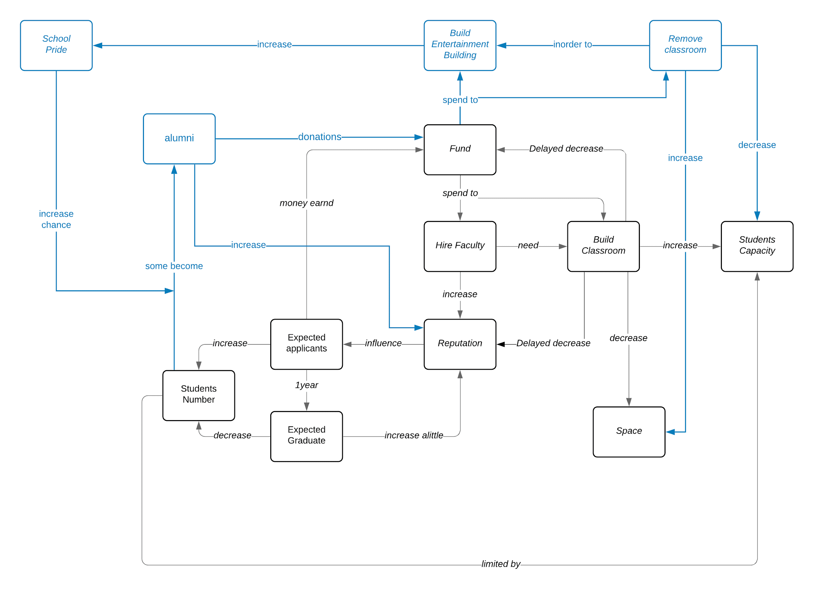
https://bit.ly/2XhN9MU

As shown in the above figure, more resources will be introduced in the late-game, which also affects the resources that have existed since the early-game. For instance, the “School Pride” resource increase the amount of alumni donations as funding, which makes it different from the system of a research-oriented university. Under this design, the player needs to balance the number of entertaining facilities and classrooms in order to maximize alumni donation while keeping a normal student population.

Since these additional economic systems are quite complicated, we’ve decided to only design the stats of the “Research-Oriented” path.

Research points: the special research facilities’ level/reputation of faculties/number of master and Ph.D. students also positively contribute to research points.

The player can choose to use these research points to conduct research projects. The more challenging research projects reward more reputation and funding but they will take longer and cost more funding.

